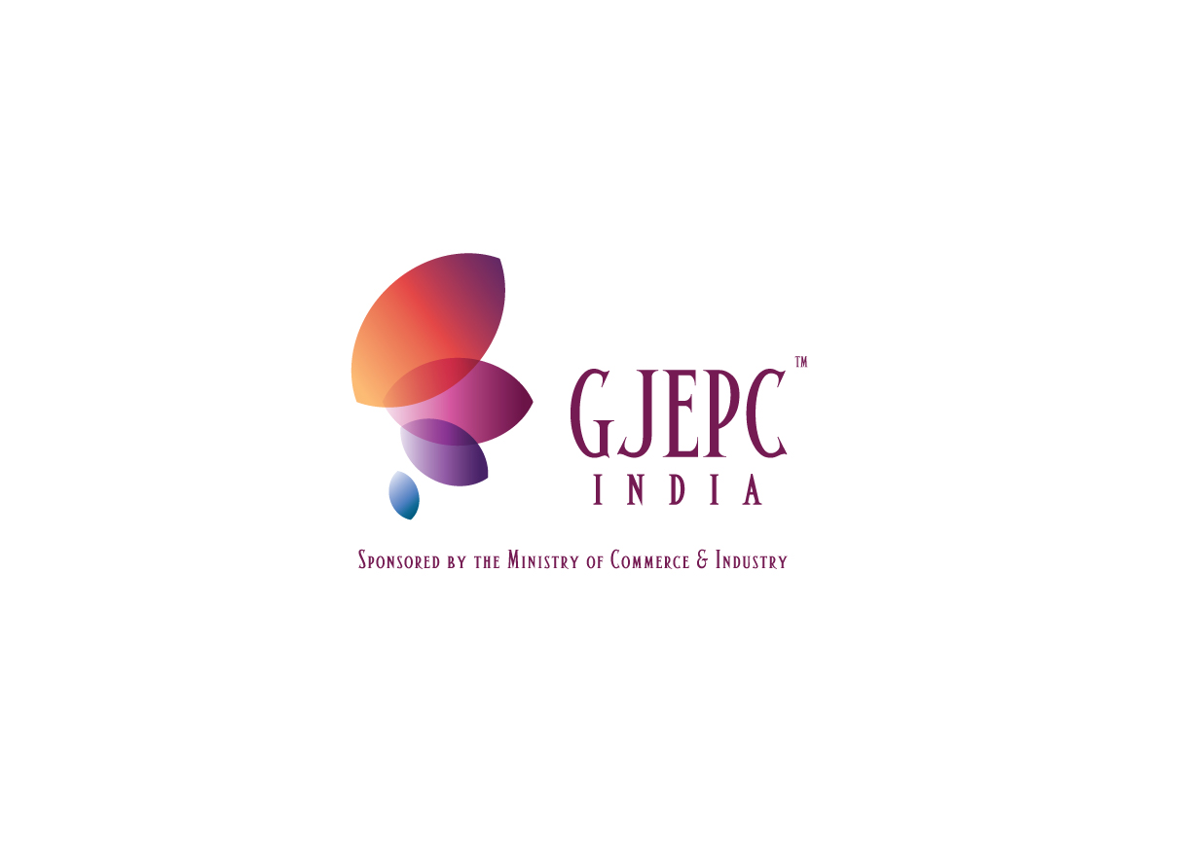

GEM TESTNG LABORATORY
Rajasthan Chamber Bhawan, M.I. Road, Jaipur – 302 003
Phone: 91-141-2568221, 2573565 Fax: 91-141-2567921
Email: gtl@gjepcindia.com
Website: www.gtljaipur.info

Application For ‘Corporate Discount Membership’
Date: …………………………………

Name of the Firm / Company
Name of Partner(s) / Proprietor (s)
Address
Phone (Landline)
Phone (Mobile)
Email
Website
Firm / Company Registration No.*
If member of the Gem & Jewellery Export Promotion Council | Yes No
If yes, please give membership no.
Copy of membership certificate enclosed | Yes No

* Registration number with Sales Tax Authority; please enclose self attested a copy of registration certificate

Payment of Rs. 15,000/- must be accompanied with this application. Cheque or Demand Draft should be drawn in favour of ‘Gem Testing Laboratory’ payable at Jaipur.

Mode of Payment (please tick )
Cash Cheque Demand Draft

Cheque / Demand Draft No…………………………………………..………. Dated………………….…………….
Drawee Bank Name………………………………………………………………………………………………….…………

For Office Use:
Application received on:…......……………………….
Membership No…………………………………........….
Membership issued on:…………........………………

Authorised Signatory……………………........………..
(For GTL Jaipur)

I/We have read and understood the terms and conditions governing the usage of Corporate Discount Membership. I/We accept to be bound by the terms and conditions and to any changes made therein from time to time by Gem Testing Laboratory, as its sole discretion without any notice to me/us.

Authorised Signatory
(please put seal / stamp of the firm / company)
'Corporate Discount Membership' - Terms & Conditions

- In order to give extra benefits to the regular users of the jewellery identification and diamond jewellery grading services of GTL Jaipur the laboratory offers a ‘Corporate Discount Membership’, under which a membership holder will get discount of 30% on the prevailing certification charges.
- In order to give extra benefits to the regular users of the services of the Gem Testing Laboratory, Jaipur, the laboratory has introduced a ‘Corporate Discount Membership', by which a membership holder will get discount of 30% on the prevailing charges of diamond and coloured stone jewellery certification.
- The above discount will be applicable only on diamond and coloured stone jewellery and not on single stones, packet lots (loose stones), or bead strings.
- This membership shall be given to those clients who submit a minimum guarantee of 1000 carats per year and against a security deposit of Rs. 15,000 per year which will be valid for maximum period of one financial year, beginning on 1st April of each calendar year.
- The membership will expire on 31st March of the year and will become invalid for availing discount on 1st of April of the same year, unless it is renewed. Therefore it is advisable that it should be renewed by 31st of March.
- The membership will expire on 31st March every year and if desired by the client, the security amount of Rs. 15,000/- shall be carried forward to the next financial year.
- The discount will be applicable on a membership from the date of its issuance. For example, if a membership is renewed on 30th April, the holder cannot claim discount on testing done on 29th April or before.
- In case, a client takes the membership in middle of the year, guarantee of minimum quantity of diamonds submitted for grading shall be considered on pro-rata basis.
- The membership commences from the day of deposit of security deposit and hence the discount of 30% on every bill. The security amount may be refunded to client on completion of target of 1000 carats.
- If a client is unable to complete the target of 1000 carat, the security amount of Rs. 15,000 will be forfeited, which will include service tax.
- Discounted rates are being calculated on the existing certification charges. In case of revision of the rates, the final discounted rate shall also change. The Gem Testing Laboratory reserves the right of revision of the certification charges without any prior intimation to the membership holder.
- The Gem Testing Laboratory reserves the right to terminate the scheme of ‘Corporate Discount Membership'. However, the existing membership holders for a particular period shall be given the discount as may be decided by the laboratory.
- Decision of the Gem Testing Laboratory, Jaipur will be final in case of any dispute(s).
- Courts of Jaipur shall have exclusive jurisdiction to settle any dispute which may arise out of, under, or in connection with these Terms and Conditions.
- Applicant firm / company must be a registered firm with the sales tax authority. A copy of registration certificate should be submitted along with the application form.
- If the firm / company is a member of the Gem & Jewellery Export Promotion Council, then a copy of current membership certificate should be submitted along with the application form.
- While submitting the jewellery for certification, the depositor should produce the Membership number for availing the discount.
- Discount under 'Corporate Discount Membership' cannot be combined with any other offer.

Signature of Authorised Signatory
(Please put seal / stamp of the firm / company)
Name of the Firm / Company

………………………………………………………………………….

